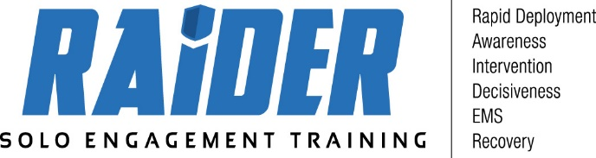

**Class Requirements**

**1. The student will need:**

a. Long sleeve shirt for airsoft force on force training

b. Pen and paper

c. Cup (Optional but not a bad idea)

d. Gloves

**2. Unless otherwise instructed, ALL courses begin each day at 8:00 a.m.**