RAIDER Training - 2 days ($595)
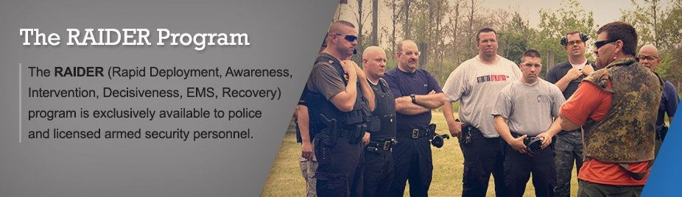
Hosted by: West Green School District
7-23-20 to 7-24-20
West Green JR/SR High School
1352 Hargus Creek Rd.
Waynesburg, PA 15370
For more information or to register, log on to www.raidertraining.com or contact
Chris Pattie at 440-785-8733/Email cpattie@raidertraining.com

PREREQUISITE: ACTIVE POLICE OFFICER, MILITARY, OR ARMED SECURITY
The RAIDER (Rapid Deployment, Awareness, Intervention, Decisiveness, EMS, Recovery) program is exclusively available to police, military, and licensed armed security personnel.
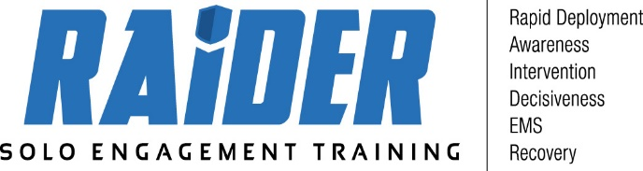

Addressing Unique Challenges
RAIDER exposes first-on-scene responders to the tactical skills necessary to operate in the unique Active Shooter setting – a hostile environment, populated by large numbers of civilians, with an Active Shooter attempting to achieve the highest body count possible in the shortest amount of time. This is not a normal event, nor is the response.
Solo-Engagement Tactics
There will always be a first officer on the scene. If he or she waits for more officers – as is the protocol in many units – who are we portraying needs help more - the officer or the victims under attack? Solo-engagement training is designed to provide officers with the necessary mental and physical skills to draw the attention of the active shooter away from the potential victims, confuse and frustrate the shooter, and successfully neutralize the situation.
The Course
Our leveled courses are designed to provide Officers with a new skill set of moving alone in hostile environments. The courses involve classroom, range, and scenario instruction and are delivered in a logical progression.

RAIDER Level 1
Day 1: 0800 - 1000
Setting: Classroom
Background and Introduction - Necessity of solo-engagement
Case studies / History of Active Shooters
Day 1: 1000 - 1700
Setting: Building for Drills and Movements (airsoft)
Introduction to solo engagement movements
Team movement vs Solo movement comparison
Movement Exercises (Left Turn, Right Turn, Reverse) Solo
Engagement Tactics
• Entry & Exits from Hallways
• Clearing Rooms
• Clearing Hot zones (Solo)
• Entry with multiple threats
• Shoot/No-Shoot Targets

Day 2: 0800 - 1700
Setting: Building for Drills and Movements (airsoft)
• Entry & Exits from Hallways
• Clearing Rooms
• Clearing Hot zones (Solo)
• Entry with multiple threats
• Shoot/No-Shoot Targets and force on force

