RAIDER Training - 2 Days ($595)

4-Day Operator ($850 Includes Level 1)

5-Day Instructor ($995 Includes Level 1 and 2)
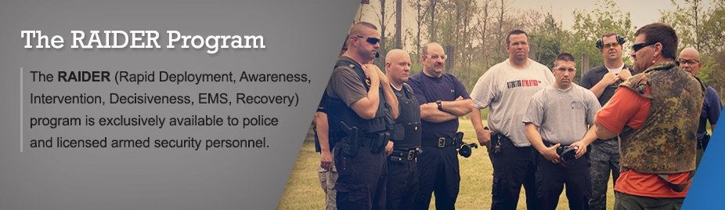
Hosted by: Warrensburg Police Dept
7-6-20 to 7-10-20
Warrensburg Police Department
102B S. Holden St.
Warrensburg, MO 64093
For more information or to register, log on to www.raidertraining.com or contact
Chris Pattie at 440-785-8733/Email cpattie@raidertraining.com

PREREQUISITE: ACTIVE POLICE OFFICER, MILITARY, OR ARMED SECURITY
The RAIDER (Rapid Deployment, Awareness, Intervention, Decisiveness, EMS, Recovery) program is exclusively available to police, military, and licensed armed security personnel.
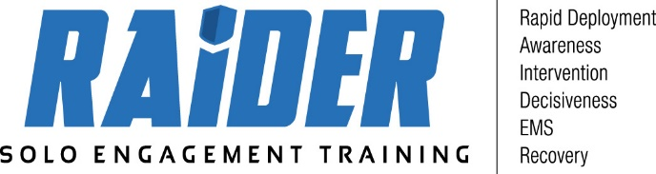

Addressing Unique Challenges
RAIDER exposes first-on-scene responders to the tactical skills necessary to operate in the unique Active Shooter setting – a hostile environment, populated by large numbers of civilians, with an Active Shooter attempting to achieve the highest body count possible in the shortest amount of time. This is not a normal event, nor is the response.
Solo-Engagement Tactics
There will always be a first officer on the scene. If he or she waits for more officers – as is the protocol in many units – who are we portraying needs help more - the officer or the victims under attack? Solo-engagement training is designed to provide officers with the necessary mental and physical skills to draw the attention of the active shooter away from the potential victims, confuse and frustrate the shooter, and successfully neutralize the situation.
The Courses
Our leveled courses are designed to provide Officers with a new skill set of moving alone in hostile environments. The courses involve classroom, range, and scenario instruction and are delivered in a logical progression.

RAIDER Level 1
Day 1: 0800 - 1000
Setting: Classroom
Background and Introduction - Necessity of solo-engagement
Case studies / History of Active Shooters
Day 1: 1000 - 1700
Setting: Building for Drills and Movements (airsoft)
Introduction to solo engagement movements
Team movement vs Solo movement comparison
Movement Exercises (Left Turn, Right Turn, Reverse) Solo
Engagement Tactics
• Entry & Exits from Hallways
• Clearing Rooms
• Clearing Hot zones (Solo)
• Entry with multiple threats
• Shoot/No-Shoot Targets

Day 2: 0800 - 1700
Setting: Building for Drills and Movements (Airsoft)
Review of Solo-Engagement Tactics

RAIDER Level 2

Day 3: 0800 - 1700
Setting: Range
Range Safety Briefing: Existing range instructions shall be adhered to and the hosting agency has final authority regarding range operations.
Tactics and Shooting Drills: Single and multiple person exercises involving critical thinking, physical movement and target engagement in a populated setting. Building of skill set to use speed, positioning, entry and exit techniques, and distractions to move aggressively, but not recklessly, to contact.
Combative: Techniques and methods of dealing with hostiles and friendlies in a dynamic environment will be presented and practiced.

Day 4: 0800 - 1700
Setting: Range
Range Exercises: Exercises and scenarios to simulate solo tactics and engagement during an Active Killer event.
Link Up Drills
Scenarios simulating past Active Killer events will be replicated in order to practice aggressive movement to contact threat.
Live-Fire Scenarios with coordinated response procedures (EMS)
First Aid: Provide the attendee with knowledge of fast methods for treating wounded persons and recovery of the injured.
Force on Force Drills -Airsoft training weapons will be utilized

RAIDER Level 3 (Instructor Course)

Day 5: 0800 - 1700
Setting: Building/Range
Review of the drills and exercise of the RAIDER Level 1 course
Instructor Candidates lead drills and critique other students
Review drills from RAIDER Level 2 course with the instructor candidates leading and instructing each other in Live-Fire drills and exercises
Drills from RAIDER Level 2 course with the Students leading and instructing each other in Non-Live-Fire drills and exercises, and Force-on-Force scenarios.

